Group of Twenty (G 20)

A Reading for Students of Classes IX, X, XI and XII

Ministry of Education
Government of India
Group of Twenty (G 20)
Learners! You are aware and must have learnt in your Social Science classes how international forum like United Nations Organization (UNO) came into being to bring together and work with nations of the world for peace, development and strengthening relationship and cooperation among the nations and peoples of the world. Some of these organisations are at the global level, they are international and some of them are at the regional level. Why do countries come together to form an organization? Do they have a common cause or interest? Yes. If you have guessed it, you are absolutely right. They come together for a common cause and mutual benefit and understanding, and to make the world a better place to live in. You must have also learnt about Non-Aligned Movement (NAM), South Asian Association of Regional Cooperation (SAARC), European Union and so on. Do you know about G20? How it came into being? Let us explore and learn about G20.
Learners! Group of Twenty known as G20 is a forum for international economic cooperation. India has assumed its Presidency on 1st December 2022 and will hold it till 30th November 2023. It is a proud moment for all in India as citizens and for the countries in Asia and Africa and also for all other countries for India has taken over the G20 Presidency at a crucial period of time in history. It is also apt that India heads the G20 as India is the Fountain Head of Democracy as the first Republic of the world originated in the Ancient India. India is imbedded with the spirit of democracy since more than 3000 years and has been always at the forefront of cooperation. G20 forum gives India the unique opportunity to communicate its democratic ethos to the world.
The G20 was founded in 1999 after the Asian financial crisis as a forum for the Finance Ministers and Central Bank Governors to discuss global economic and financial issues. As you are aware that the Central Bank in India is known as the Reserve Bank of India. As a premier forum for international economic cooperation, G20 plays a vital role in shaping and strengthening global architecture and governance on all major international economic issues. G20’s role as international forum was recognized through its initiatives for economic and mutual cooperation of member countries and the Group of Twenty was strengthened and upgraded to the level of Heads of State and during the global financial crisis of 2007 and got designated as the ‘premier forum for international economic cooperation’. This makes G20 truly an international organization for economic cooperation among its member countries.
Who are G20 members?
G20 comprises 19 countries and an organization of countries known as the European Union as members. The members of G20 are: Argentina, Australia, Brazil, Canada, China, France, Germany, India, Indonesia, Italy, Japan, Republic of Korea, Mexico, Russia, Saudi Arabia, South Africa, Türkiye, United Kingdom and United States and the European Union. The countries are from across the world and these members represent around 85% of the global GDP, over 75% of the global trade, and about two-thirds of the world population. This is why G20 is an important organization from the current economic, political and socio-cultural contexts as every country endeavors to enable themselves to economic develop and be a self-sustaining country in the context of globalization.
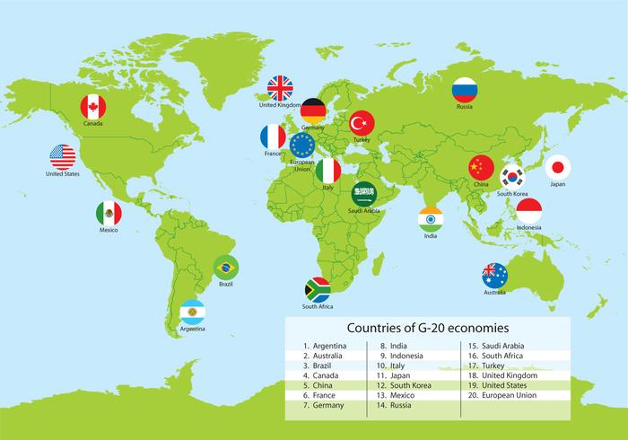

G20 LOGO
Do you know G20 LOGO and its meaning?
G20 LOGO has been designed to convey the essence and indigenous wisdom of India. You can see below as it depicts the overarching vision of human existence Vasudhaiva Kutumbakam, the World is one family. G20 website g20.org was recently launched by Honorable Prime Minister of India, Shri Narendra Modi and India took over the official social media handles, including the twitter handle @g20org, from the previous Presidency, Indonesia.
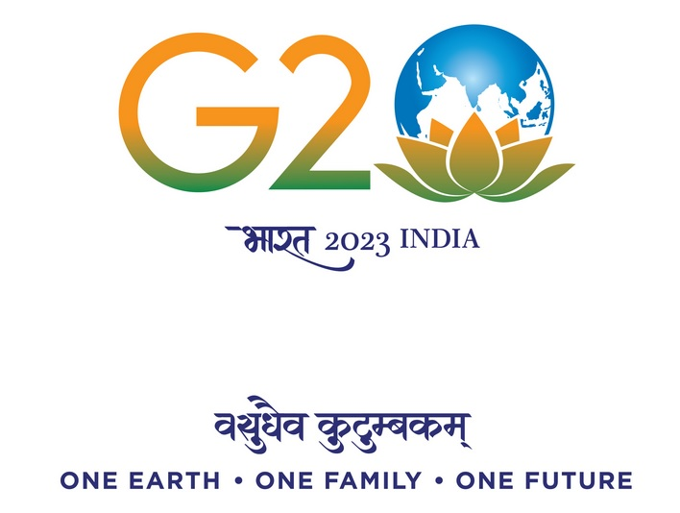
The G20 Logo has drawn inspiration from the vibrant colours of India’s national flag – saffron, white and green, and blue. It juxtaposes planet Earth with the lotus, India’s national flower that reflects growth amid challenges. Theme affirms the value of all life –human, animal, plant, and microorganisms – and their interconnectedness on the planet Earth and in the wider universe. Further, the LOGO, as you can see, has G 2 with earth in place of zero on the lotus, our national flower. Under which it is written Bharath in Hindi 2023 and India in English. The inspiring quote from the ancient Sanskrit text, Maha Upanishad, Vasudhaiva Kutumbakam - One Earth One Family One future illustrates India’s message to the world -‘the World is one family’. The need to live together and living with others. This G20 theme underscores the need for peaceful co-existence and mutual care. This makes the countries and peoples of the world understand and realize the importance of making a better world for us and our future generations to come.
What are G20 agenda?
If we notice closely the G20 was launched as a forum for economic cooperation focusing majorly on broad macroeconomic issues, but in due course of time and recognizing the need it has expanded its agenda and includes trade, climate change, sustainable development, health, agriculture, energy, environment, and anti-corruption. The agenda and mandate of G20 now addresses the needs of the current times in order to deliberate on and benefit its members.
How does G20 Presidency steer the G 20 Agenda?
- The G20 consists of two parallel tracks: the Finance Track and the Sherpa Track.
- Finance Ministers and Central Bank Governors lead the Finance Track
- Sherpas lead the Sherpa Track after Finance Track.
- A Sherpa is the representative of a Head of State or Head of Government who prepares an international summit. The name is derived from the Sherpa people, a Nepalese ethnic community, who serve as guides in the Himalayas. That is why the name here.
- Within the two tracks, there are thematically oriented working groups represented from the relevant ministries of the members as well as from guest countries and invited international organizations.
- These working groups meet regularly throughout the term of each Presidency. The Sherpas oversee negotiations over the course of the year, discussing agenda items for the Summit and coordinating the substantive work of the G20.
There are also Engagement Groups which bring together civil societies, parliamentarians, think tanks, women, youth, labour, businesses and researchers of the G20 countries.

Life Style For Environment (LiFE)
One of the themes in the G20 Agenda is the concept of LiFE (Life Style For Environment) with the aim of living in harmony with nature for a sustainable living. The idea was enunciated by our Prime Minister Shri Narendra Modi at Glasgow in the Conference of Parties (CoP 26) in 2021. We are aware that the environmental degradation is affecting the lives of people in every region. LiFE envisages a way of living which respects nature and other organisms co-exist with us, the humans for a greener and cleaner earth.

What are G20 Initiatives and Activities?
G20 brings together the world’s major developed and developing economies, making it a premier forum for international economic cooperation. Let us understand this a bit more. This is a forum which binds the developed and developing economies in order to mutually benefit from one another. In a way this forum attempts to reduce the inequality and disparity among the world economies.
Government of India has initiated many activities, events across the country during its presidency. A key element will be taking the G20 closer to the public and making it truly a ‘People’s G20’. To realize this, citizen engagement and large scale public participation through various Jan Bhagidari activities are planned throughout the year. India will host over 200 meetings in over 50 cities across 32 different work streams, and would have the opportunity to offer G20 delegates and guests a glimpse of India’s rich cultural heritage and provide them with a unique Indian experience. The Hornbill Festival in held in Kohima during December 2022 when India took over the Presidency of G20 featured a special focus on G20. One hundred monuments, including some UNESCO world heritage sites were illuminated and citizens were invited to join a selfie campaign on MyGov around these illuminated monuments.
Some Countries and International Organizations are invited as Guests to the G20 Summits and meetings. Here are the countries.
International Organizations invited as Guests
United Nations, International Monitory Fund (IMF), World Bank (WB), World Health Organization (WHO), World Trade Organization (WTO), International Labour Organization (ILO), Financial Stability Board (FSB) Organization for Economic Co-operation and Development (OECD) and many more regional organizations like the Asian Development Bank (ADB).
What are the activities for students?
There are many activities and events for school and university students. Some activities have already been launched / started. Here are the activities:
- General awareness Quiz on G20
- Life Style for Environment (LiFFE) Quiz
- Slogan Writing Competition on G20
These two quizzes and the slogan writing completion are available on https://quiz.mygov.in
- Exhibition of best practices of technology enabled activities (Augmented Reality (AR) and Virtual Reality (VR) exhibition for school students.
- Science Exhibitions
Many more activities for school students to participate and contribute to make the G20 closer to students, teachers and people as a whole. Learners, you can refer to the dedicated G20 website g20.org and from Ministry of Education, Government of India’s website and also from NCERT website.
Learners we have learnt about G20, its purposes, activities and how India’s presidency has proposed many activities for all to participate and contribute. Now try the following questions based on your reading on G20.
- How do you think India can benefit from its G20 Presidency?
- What can India offer to the G20 countries as its President?
- As a student write a letter to the Prime Minister of India suggesting him an important idea, point or action for school students in the G20 agenda for G20 and other countries?
- What would you suggest for a greener and cleaner environment to G20 countries and their leaders?

